NIST user Guide
- How do I chose the file of NistBootcode.bin
  - Merge NistBootCode_Jump.bin in build.sh while developing phase to ensure EC can’t fetch ec code from EEPROM.
  - Merge it82202_NistBootCode_v001.bin in build.sh when you want to fetch ec code from EEPROM.
- How to create the private/public key?(windows)
  - Open the OpenSSL folder, and follow instructions in OpenSSL Generate Key.docx.
- How to build the bin file to flash on EEPROM? (windows)
  - Remove first 32kbyte of zephyr_Full.bin(160kb), so you could get the remain content that name the file as zephyr_Full_128k.bin(main code).
  - Take it82202_NistBootCode_v001.bin(boot code).
  - Follow steps as below picture, you will get the release.bin.
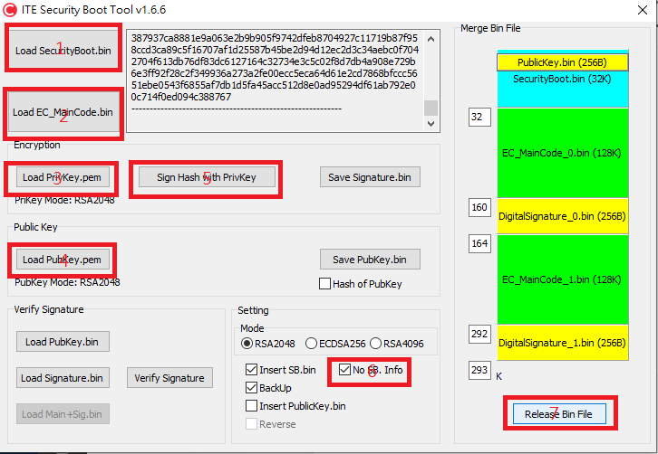
Note: EC code is fixed on 128KB, if you want to change the fw size please let ITE know, we will provide another boot code the fit this change.

